Warcraft 1, officially known as Warcraft: Orcs & Humans, was the game that started it all! Released in 1994 for MS-DOS, it was a real-time strategy (RTS) game developed and published by Blizzard Entertainment.

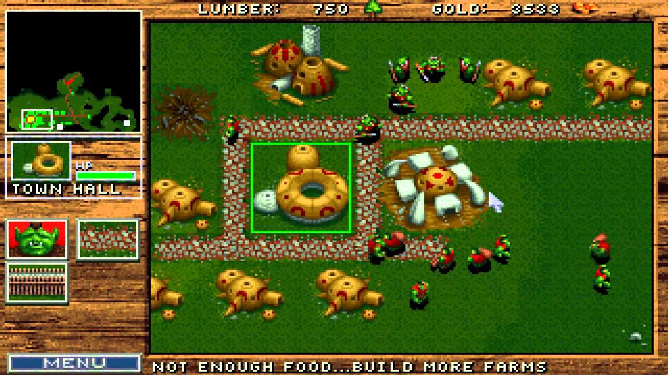

Warcraft 1, officially known as Warcraft: Orcs & Humans, was the game that started it all! Released in 1994 for MS-DOS, it was a real-time strategy (RTS) game developed and published by Blizzard Entertainment.

Compared to later Warcraft titles, the graphics and gameplay of Warcraft 1 might feel dated by today's standards.

However, it's still considered a classic and holds historical significance in the gaming world.

If you're interested in experiencing the origins of the Warcraft universe and how RTS games evolved, you might find it worth checking out (through emulators or digital purchase on GOG.com).